**Exp. 1** **Design an LED flasher**

**Circuit Diagram**:

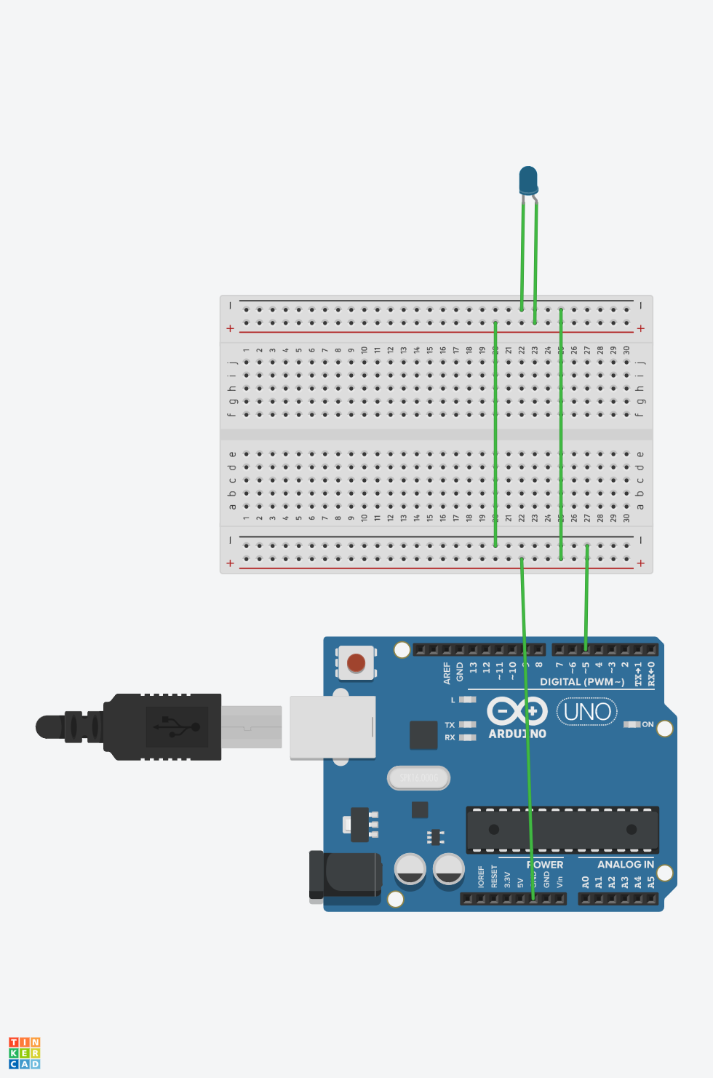

**Theory:**

Concepts Used:

1. Introduction to Arduino uno.
2. Using of Light emitting diode.
3. Code with arduino
4. Work with breadboard.

**Learning & Observations**:

Observed the use of breadboard. Understood the use of LED. Clear the concept of the working of Arduino.

There are many uses of Arduino in electronic field . We can make many devices for eg drones using Arduino.

**Problems & Troubleshoot.**

Unknowingly the negative terminal of LED is connected to the digital output of Arduino.

Know the mistake and learned the positive and negative terminal of LED and positive terminal connected to the digital output and negative terminal connected to the ground.

**Precautions and measures**

1. Determine the LED and Arduino are working properly.
2. Declare pins use .
3. Declare pin to which the positive terminal of LED is connected via coding.
4. Connect positive terminal of elements to the digital output and negative terminal to the ground by neat and clean connection.

**Learning Outcomes**

Learned Arduino coding and it was really good and knowledgeable . Understood the uses of Arduino . Things I learned from Arduino are very useful.

understand the use of breadboard and LED.